**Name : Chaudhari DhirenKumar Anilbhai**

**Roll No: CE025**

**Lab : 08_1**

Code Test 1:

body:

Padding(

padding: EdgeInsets.all(50),

child: Text('Hello only padding'),

),

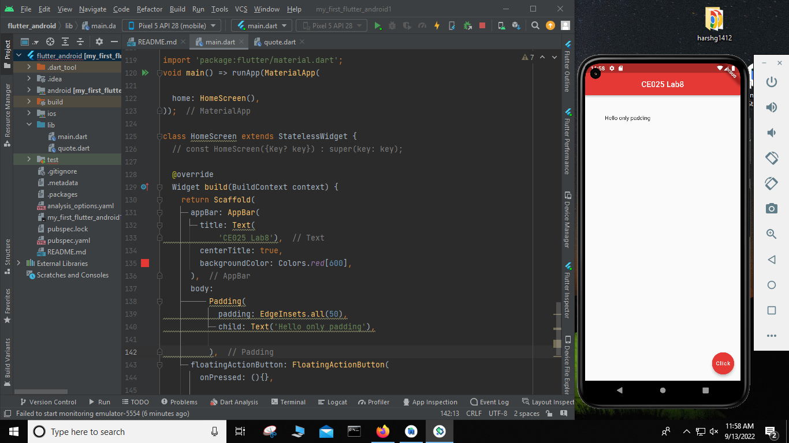

Code Test : 2

body:

Row(

children: [

Text('HELLO ROW'),

FlatButton(

onPressed: () {},

color: Colors.*purple*,

child: Text('Press Me'),

),

Container(

color: Colors.*cyanAccent*,

padding: EdgeInsets.all(30.0),

child: Text('inside container'),

)

],

),

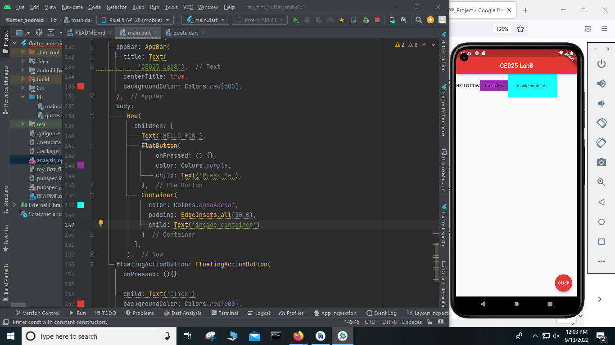

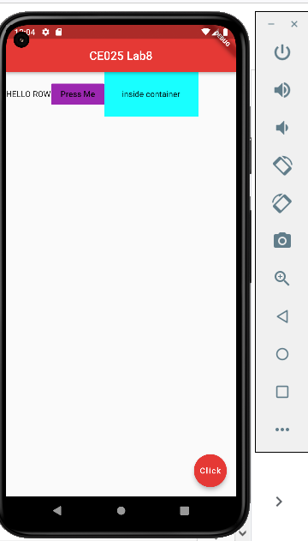

Column Test :

body:

Column(

mainAxisAlignment: MainAxisAlignment.spaceAround,

crossAxisAlignment: CrossAxisAlignment.stretch,

children: [

Text('HELLO ROW'),

FlatButton(

onPressed: () {},

color: Colors.*purple*,

child: Text('Press Me'),

),

Container(

color: Colors.*cyanAccent*,

padding: EdgeInsets.all(30.0),

child: Text('inside container'),

)

],

),

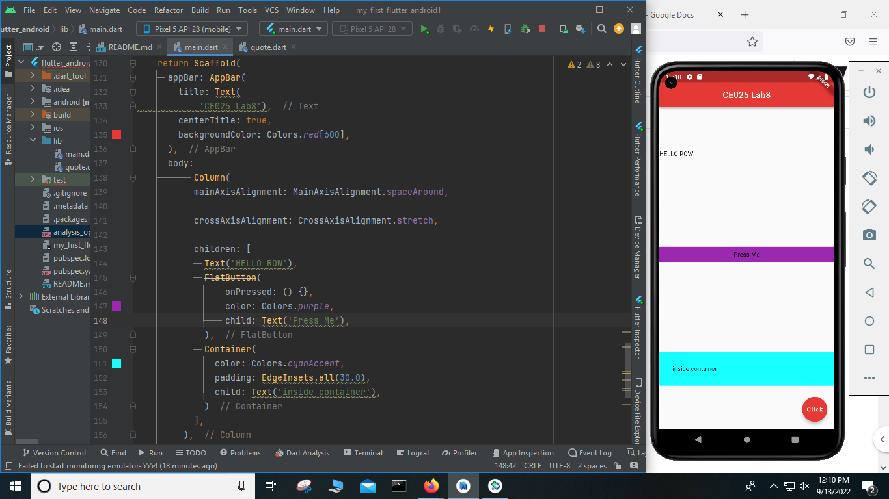

Column Changes :

body:

Column(

mainAxisAlignment: MainAxisAlignment.center,

crossAxisAlignment: CrossAxisAlignment.center,

children: [

// Text('HELLO ROW'),

// FlatButton(

// onPressed: () {},

// color: Colors.purple,

// child: Text('Press Me'),

// ),

Container(

color: Colors.*deepOrange*,

padding: EdgeInsets.all(30.0),

child: Text('inside container'),

),

Container(

color: Colors.*limeAccent*,

padding: EdgeInsets.all(50.0),

child: Text('inside container 2'),

),

Container(

color: Colors.*green*[800],

padding: EdgeInsets.all(70.0),

child: Text('inside container 3'),

), ],

),

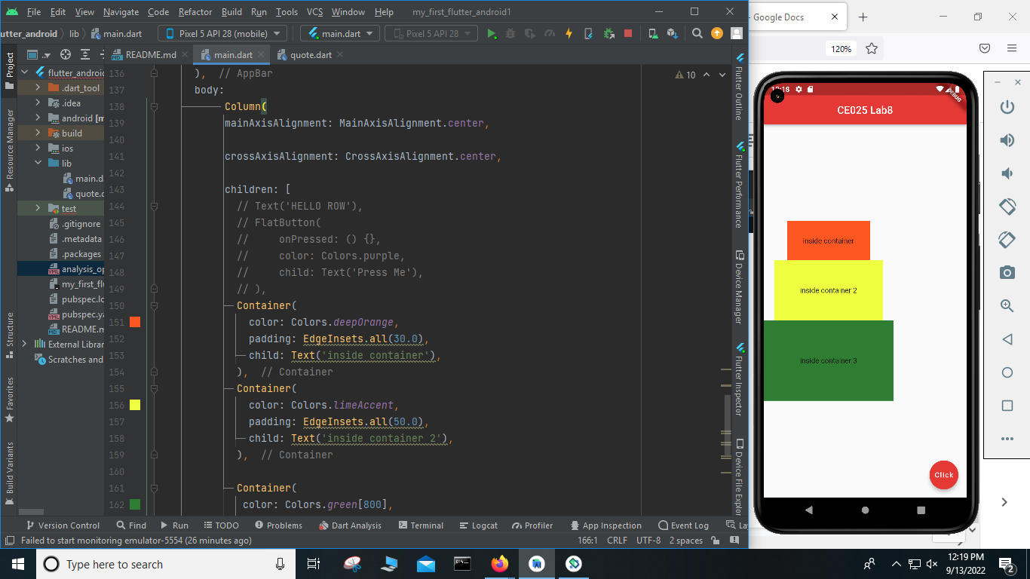

Row And Column : Test 1

body:

Column(

mainAxisAlignment: MainAxisAlignment.center,

crossAxisAlignment: CrossAxisAlignment.center,

children: [

// Text('HELLO ROW'),

// FlatButton(

// onPressed: () {},

// color: Colors.purple,

// child: Text('Press Me'),

// ),

Row(),

Container(

color: Colors.*deepOrange*,

padding: EdgeInsets.all(30.0),

child: Text('inside container'),

),

Container(

color: Colors.*limeAccent*,

padding: EdgeInsets.all(50.0),

child: Text('inside container 2'),

),

Container(

color: Colors.*green*[800],

padding: EdgeInsets.all(70.0),

child: Text('inside container 3'),

), ],

),

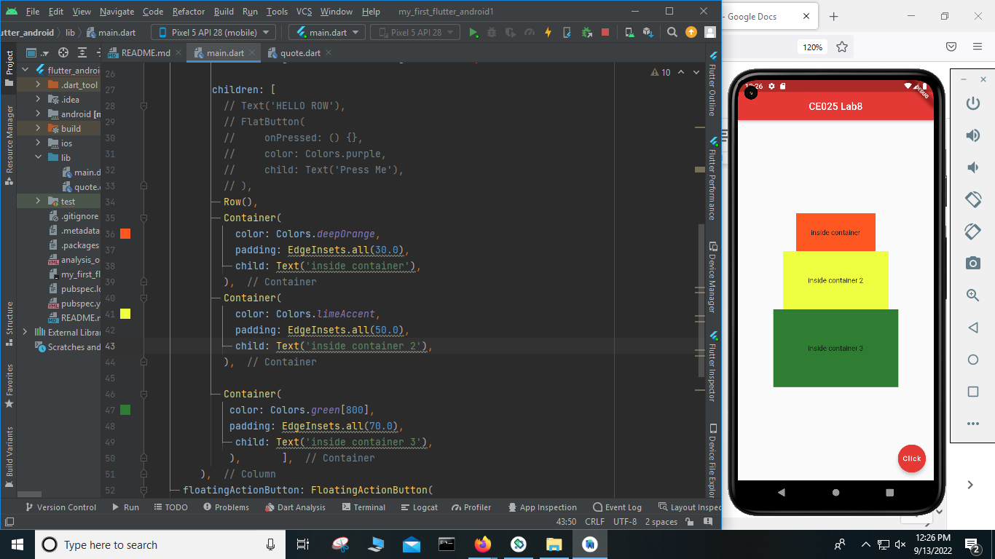

Test 2 :

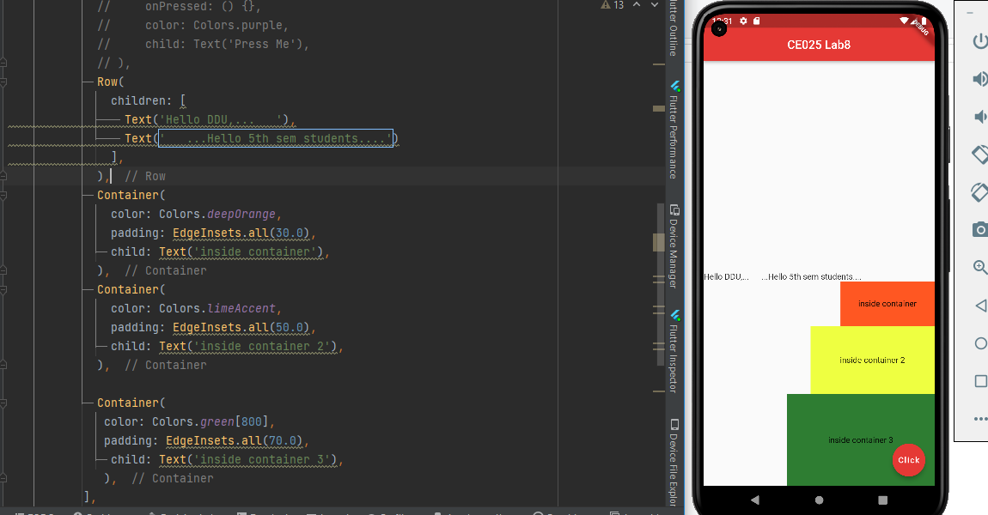

Code test: some tips and tricks:

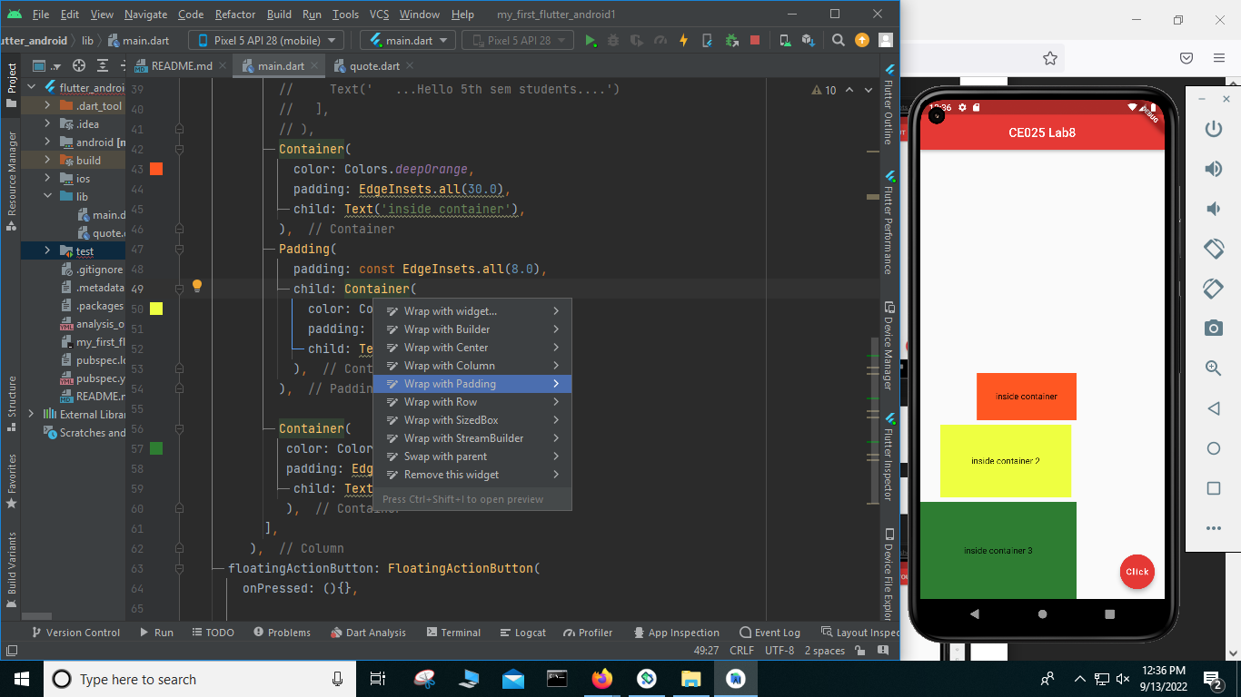

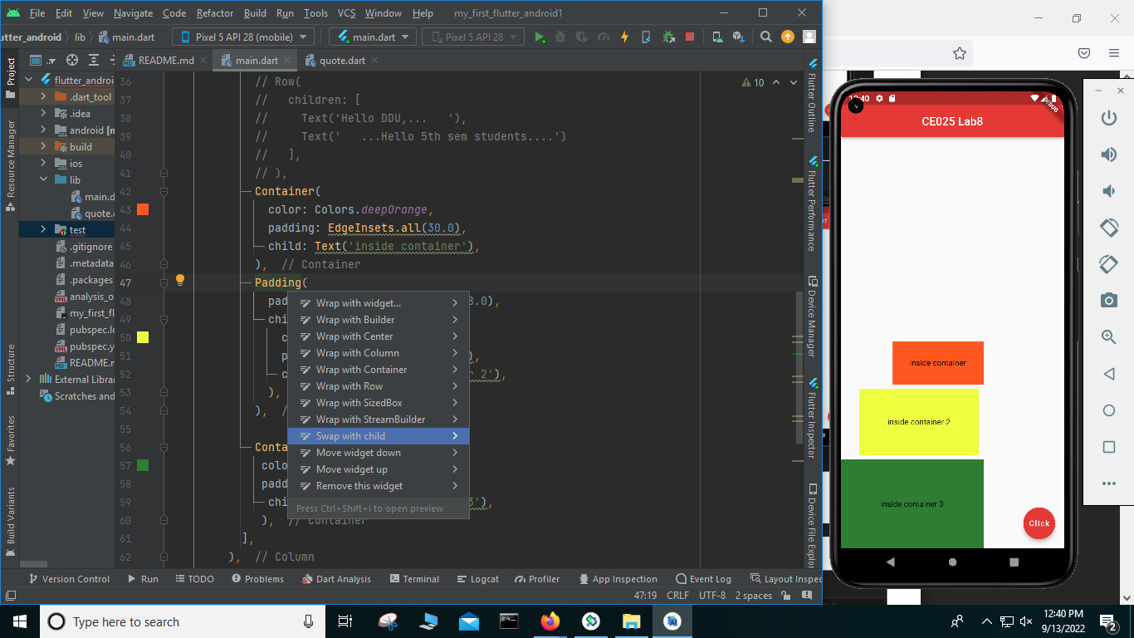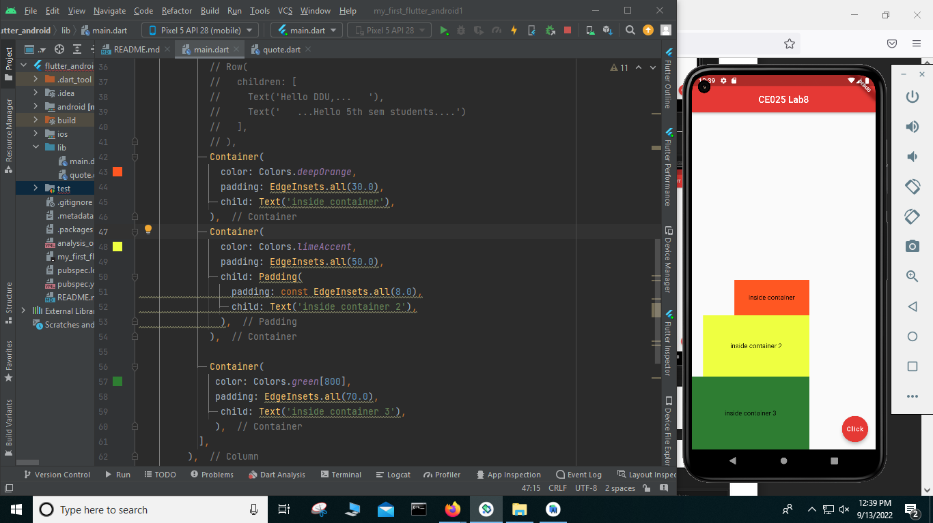

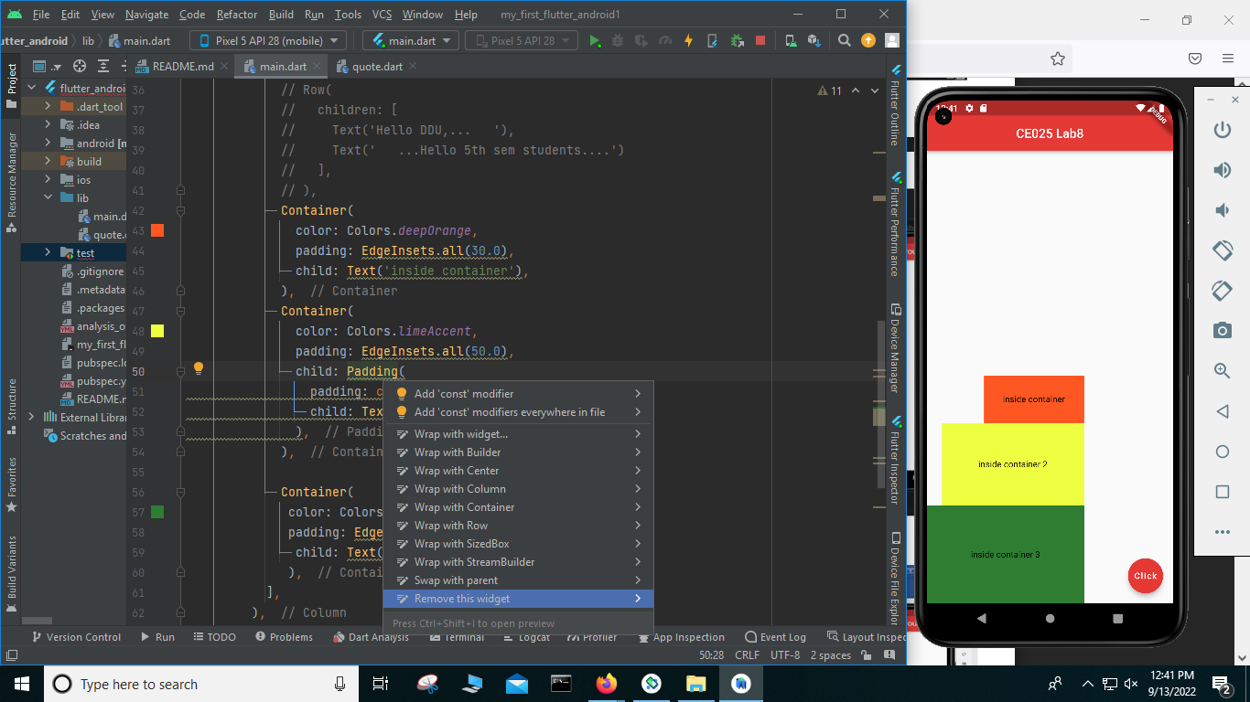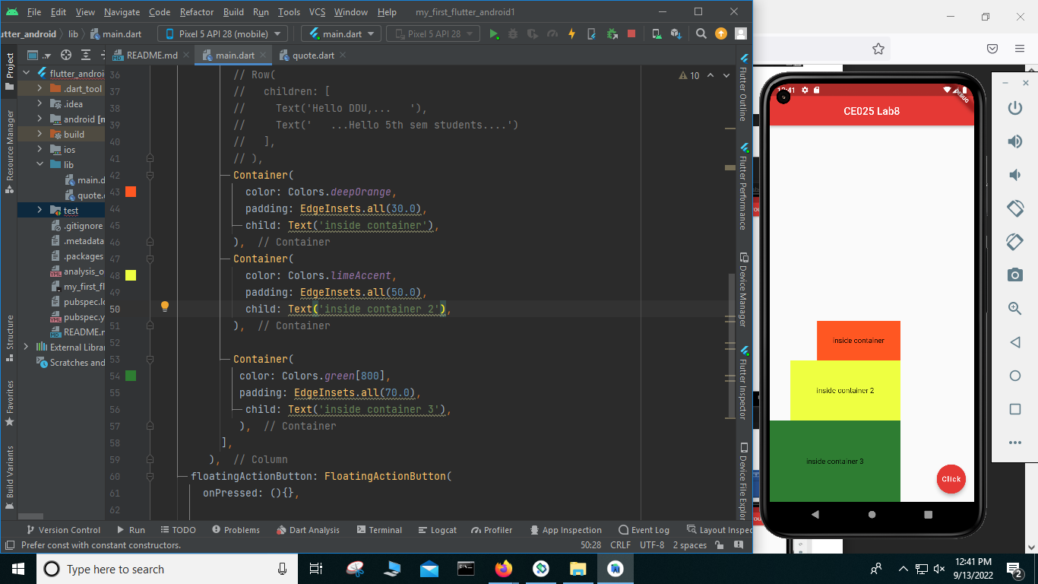

**Through flutter outline option also you can manage your project code :**

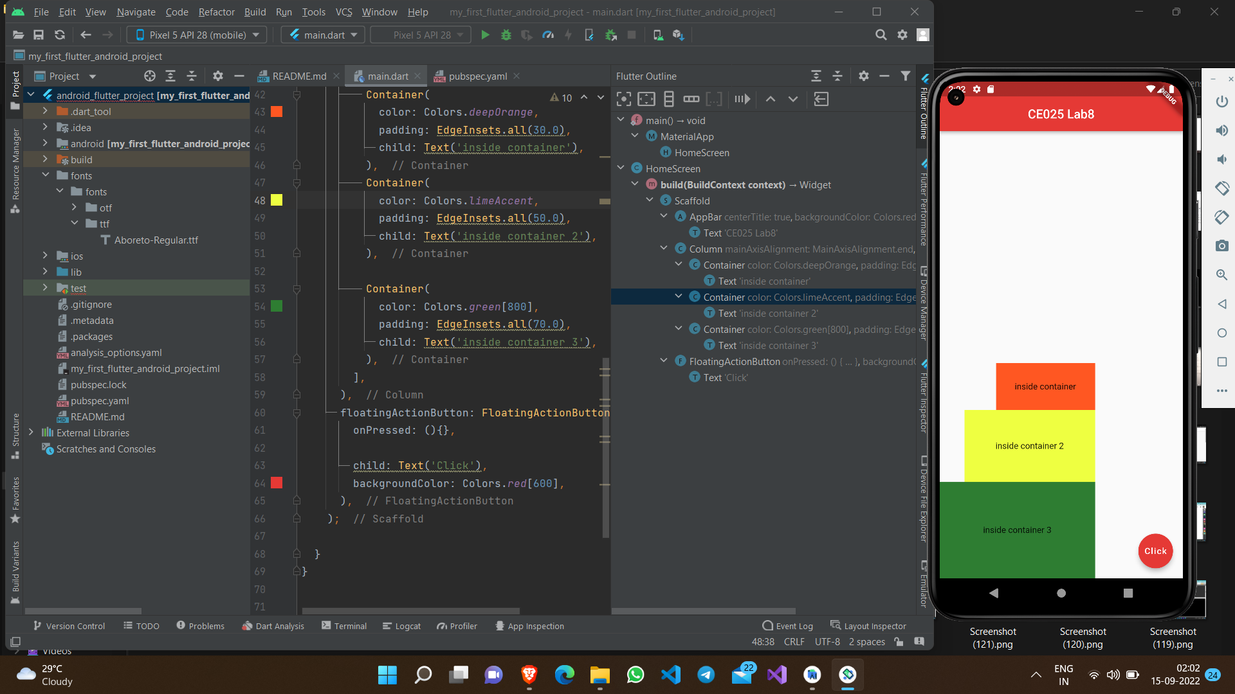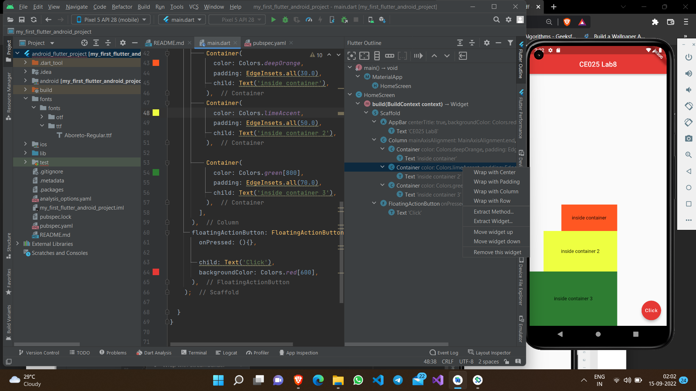

**Code test: Expanded and Flex widget**

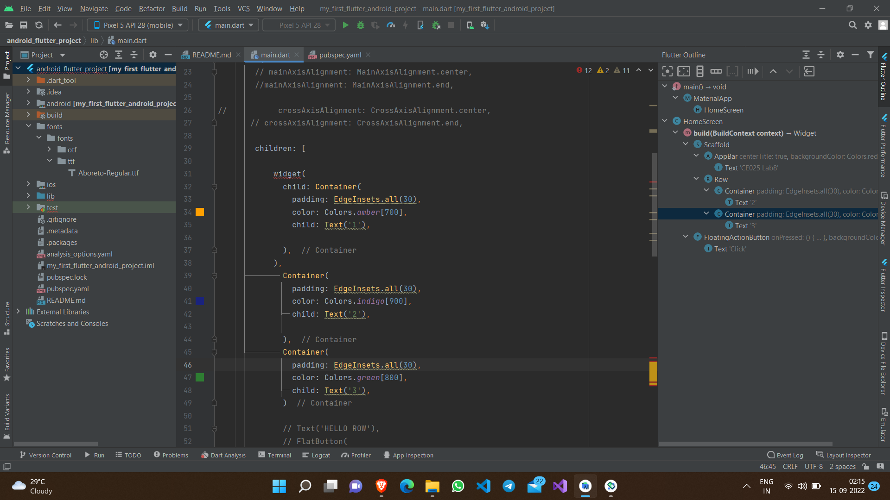

**Final Custom Design :**

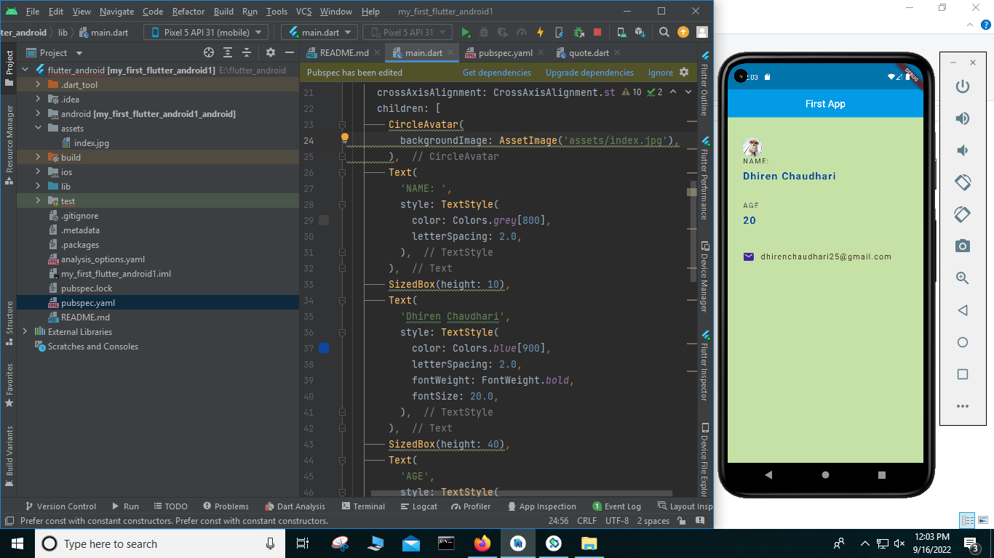

**Git Hub Link :** **https://github.com/dhiren-25/SDP.git**